Student Growth Measures in Teacher Evaluation
Facilitator’s Guide for Training Module 3:
Slide 1

Slide 4

Revisit the SLO development process.
Slide 5
Growth targets are teachers’ goals for their students. The SLO score for teachers will be determined based on the extent to which students meet their targets. Thus, creating rigorous yet attainable growth targets is critical.
Growth targets should be informed by baseline data, or prior data from each student for which the growth target is being set. This is usually from a pre-assessment or a previous year’s assessment data. However, in some cases, trend data from previous year’s assessments in the course will be needed to inform the creation of growth targets. The targets themselves should include specific indicators of growth that demonstrate an increase in learning between two points in time.
Because students will enter the class with varying levels of readiness, growth targets should be tiered, or differentiated, whenever possible and appropriate. Differentiating targets based on the baseline data of students helps ensure that all students will be able to demonstrate developmentally appropriate growth.”
Slide 6  When setting or reviewing growth targets, here are three things keep in mind. First, ALL students must be required to demonstrate growth in order to meet their target. Second, the expectations should be rigorous and challenging yet reasonably attainable. You don’t want to set growth targets that students could accomplish after just a week or two of instruction. Conversely, you do not want to set growth targets that are so challenging that they are not developmentally appropriate. Finally, growth targets should set a floor of expectations, meaning that they note the minimum performance needed in order for the growth target to be considered met. Of course, students can exceed this minimum, but the growth target should not be a range of performance. | 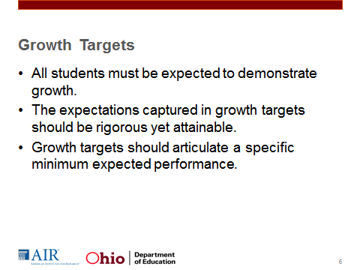
Slide 7  Begin examples of growth targets.  You will notice that they can be formatted and structured quite differently yet still meet the requirements on the SLO Template Checklist. We will move from the least complex example to more complex examples.  This target is strong in that it requires all students to demonstrate growth. One limitation of this target is that it assumes that the effort and progress required between each zone is uniform; this may not be the case. | 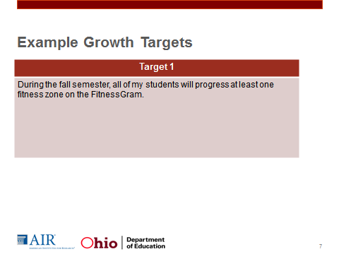
Slide 8  This target uses a formulaic approach to setting growth targets. All students are expected to increase the scores by half the difference between 100 and the pre-assessment score. Although it is a fairly straightforward approach to setting growth targets, it is not responsive to the assessment used. There are two limitations to using formulas for setting growth targets: First, some assessments may not be structured so that half the difference is an appropriate growth target. Some assessments simply aren’t designed so that growth from a 10 to a 55 is as reasonable as growth from an 80 to a 90. Second, the formula assumes that students will never score 100 on the assessment. What is valuable about using a formula is that it can provide a guide post for teachers who are using a new assessment or lack sufficient data that can support the setting of a growth target. | 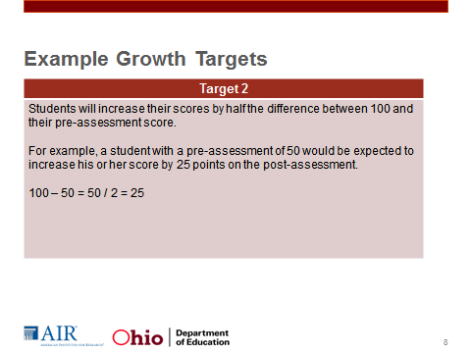
Slide 9  Here is another example of an acceptable target. This target is tiered, meaning that the target scores vary based on the pre-assessment scores of the students.  Here we see that the teacher established a target score, the minimum score the student must achieve in order for the growth target to be considered met, for each baseline score range. However, one of the drawbacks of constructing growth targets in this format is that the expected growth varies around the cut points. For example, if you score a 60, at the high end of the first baseline score range, you only have to increase your score by 10 points, but if you score a 61, then you have to increase your score by 15 points to reach the target of 85.  How you could revise Target 3 to make it stronger. Possible answers:  - Create more tiers.  - Say +15 points or something like that so everyone within a tier has to show the same amount of growth  - Set a minimum score and growth amount and expect the greater amount. (i.e. Score a 70 or increase your score by 15 points, whichever is greater). | 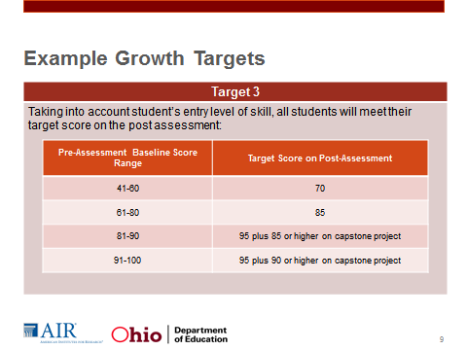
Slide 10  Target 4 is one potential revision of Target 3. If we look at the first tier, we see that students who are expected to either reach a minimum score or increase their score by a specified number of points—whichever is greater. For example, if I score 50 on my pre-assessment, my growth target will be to score 70. However, if I score a 58, my growth target will be to increase my score by 15 points, which equates to a score of 72.  The way this is structured, all students have to show at least 15 points growth in the lowest tier. Some students may need to demonstrate more growth to reach their target, but no student gets away with only having to grow 5 points.  Target score for 81-90. Here we see that students are expected to either attain a score of 85 or increase their score by 7 points, whichever is greater. This way all students in this tier have to grow at least 7 points. In addition, students must score at least 85 on a capstone project; the inclusion of a capstone project helps ensure the assessments used have sufficient stretch. | 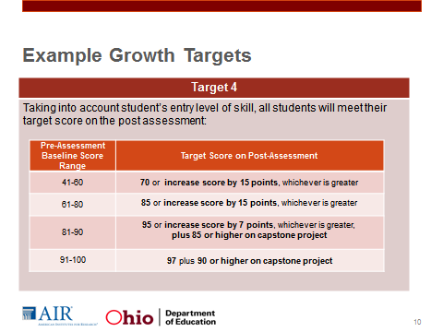
Slide 11  In some content areas, the best assessments may not be easily summarized in numerical scores. When using rubrics, sometimes descriptive targets may be appropriate. For example, in this foreign language example, proficiency is assessed using LinguaFolio Can-Do Statements, supporting evidence and a final Individualized Performance Assessment (IPA). The baseline data and growth targets are the performance levels contained on a rubric.  There are two things to note in this slide: The first is that not all assessments produce a numerical score, so in some cases descriptive growth targets are acceptable. The second point is that this growth target is based upon multiple sources of evidence. Because of this complexity, in the assessment section, the teacher would need to clearly explain how the multiple pieces of data are going to be combined and how the final performance level is going to be determined. | 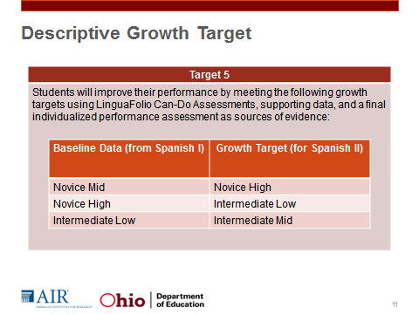
Slide 12  We have now walked through a variety of growth targets. Now let’s discuss a few that would not meet the criteria in the SLO Template Checklist. Read the target and then discuss at why this target is unacceptable and what you might suggest the teacher do to improve the growth target. | 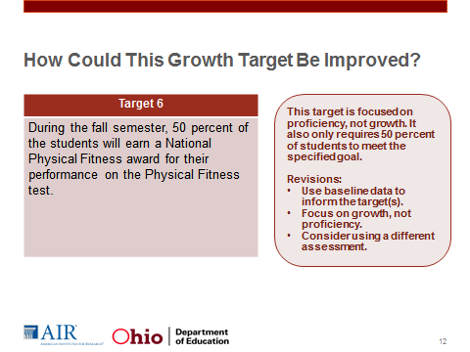
Slide 13  Here is another example in need of improvement. Please read the target and then discuss why this target is unacceptable and what you might suggest the teacher do to improve the growth target. | 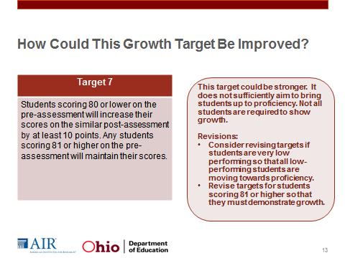
Slide 14  Target 7 is a tiered target, but it would not be approved. Why?  The score range does not add anything to this growth target. If anything, it just makes the target unnecessarily complicated. All you need here is the minimum expectation for the target to be considered met, not a whole range.  We have now looked at a variety of growth targets. What you should walk away with from this activity is the following:  - Targets can be structured in a variety of ways, and they all present strengths and weaknesses. Having conversations with peers about which format will work best for you given your purposes can be important.  - Growth targets should be based upon baseline data and should be based on growth, not proficiency, and the targets should be structured so that all students must show growth.  - Finally, targets should be rigorous yet attainable. | 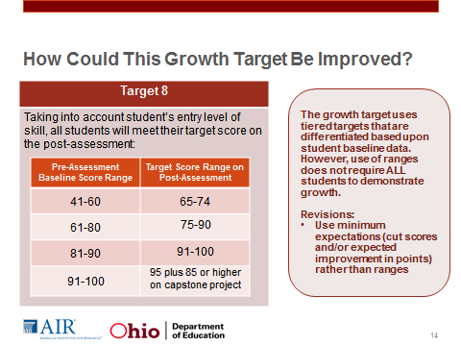
Slide 15  We have talked to this point about the format of student growth targets and how to construct targets that will require students to demonstrate growth. But how can teachers ensure that reasonable targets for students are set?  The answer is in using data. Handout 3.2 contains a chart that might be useful to teachers because it discusses the sources of data that may be used in informing growth targets: surveys, trend data, assessment data from early in the year, and course pre-assessments. It also provides some considerations when setting growth targets. For example, the structure of growth targets may vary based upon the data source used. So, if I score a 90 on the pre-assessment and I score 90 on the post-assesssment, I have not demonstrated growth. However, if instead of a pre-assessment the teacher used the results of the Spanish I end-of-course exam, maintenance of scores would still constitute growth. For example, if I scored a 90 on the Spanish I end-of-course exam and then on the post-assessment, which was the Spanish II end-of-course exam, I scored a 90 again, that would be considered growth because the assessments were not similar in scope or difficulty. In order for me to score a 90 on the Spanish II end of course exam, I needed to demonstrate a greater range of skills and knowledge than I had to on the Spanish I exam. So in some cases, maintenance of scores may constitute growth. | 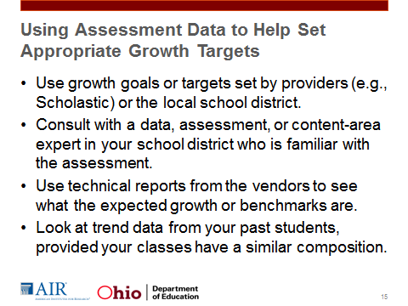
Slide 16  Here is one approach to setting growth targets. This uses a backwards mapping approach and it certainly is not the only way to approach growth targets. This approach is helpful if you have some knowledge about expected student performance, either from the test creator or from trend data. You can follow along in Handout 3.3 which provides the steps I am about to discuss plus some additional questions to think about..  First, you want to determine what baseline data you will use and select a high-quality post-assessment. Remember from our previous module that the assessment must be aligned to the curriculum, have sufficient stretch, and be valid and reliable. The assessment must have been reviewed by a content or assessment expert at the district level if it is teacher- or team-created. | 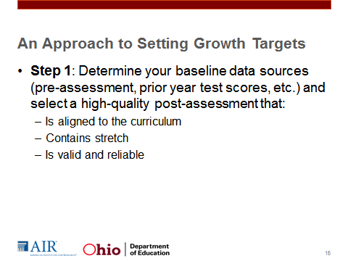
Slide 17  In step 2, you would determine what you already know about the post-assessment. What is considered a passing score on the post-assessment? What score indicates high levels of skill and knowledge related to the course? These benchmarks may vary by assessment, but this information is very important because it tells you where students should be at the end of the year. It can help you set your tiers or categories.  Step 2 requires you to use what you know about the post-assessment to create levels of achievement by creating score levels or tiers. These are the categories or groupings of students. Right now we are not placing our students in these groupings, but we are defining the range of scores associated with each grouping. In Example 1, we see that the teacher has set up three tiers. Example 2 has the same range of scores but has created 5 tiers. The number of tiers that you set is going to be determined by the distribution of student scores and what makes sense given your assessment. | 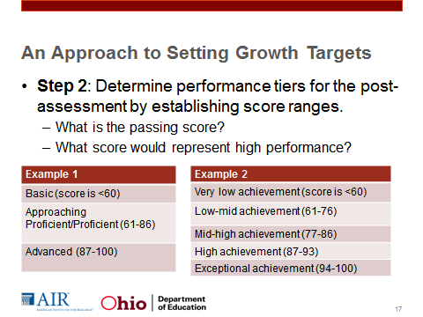
Slide 18  In step 3, you want to repeat this process for the pre-assessment or baseline data you have. If you are using a pre-assessment score as your baseline score and your pre-assessment is the same as or another version of the post-assessment, you may skip this step. | 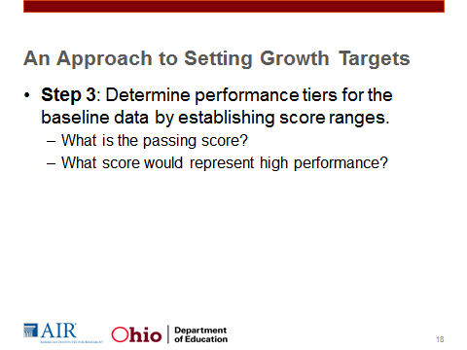
Slide 19  To this point, we have not used the student data. In step 4, you want to look at the distribution of student baseline data. Do the categories that you set work for your students? In this case we see that the five categories work pretty well for our purposes. However, if we had no one scoring in the exceptional achievement range, we might consider eliminating the exceptional achievement tier. Or, if most of our students fell into one tier based upon their pre-assessment, we might break that one tier into 2 or 3 tiers. | 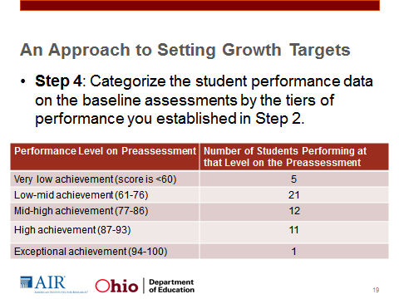
Slide 20  The next step would be to determine your expectations for growth. You may already have this information from vendors if you are using a commercially available assessment, or your district may have provided guidance on this if you are using a district-created assessment. If you do not have information already available on expected growth, you might look at trend data from the past and determine the average or median growth students made in the past within each of the tiers. In the example here, we have some student scores within a tier of the growth target and information about how much they grew. We can calculate the mean and/or median growth. Based upon this information, we can expect that approximately 17 points growth would be reasonable, or we might set a cut score around 81 or 82 given the distribution of scores.  Analyzing trend data is an imperfect approach to figuring out what expected growth is reasonable, but it is better than just arbitrarily setting expectations. Using trend data helps teachers to make informed decisions through this process. We will practice analyzing trend data in a moment. | 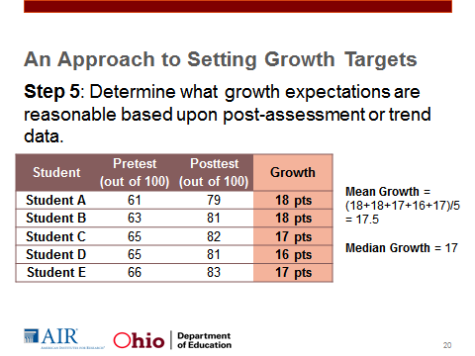
Slide 21  If you look at the diagram on this slide, you see that student A’s baseline score is 45. Based upon the teacher’s analysis of data, the teacher expects the student to attain a score of 70 on the post-assessment. Student B’s baseline score is a 75, and his expected score on the post-assessment is 90. In this example, the expected growth varies based upon the pre-assessment score, and the lower-performing student is expected to increase his or her score more than Student B. The diagram here is meant to show that based upon the assessment, uniform growth across students may not be reasonable. In some cases based on how the assessment is structured it may be reasonable to assume that lower-performing students will increase their scores more than high-performing peers, but this is not a hard and fast rule. | 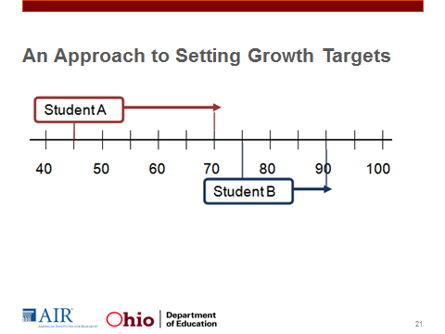
Slide 22  Once you a sense of what would be considered reasonable growth expectations, you can set your growth targets.  In this example, students are expected to reach the cut scores, which are set to be halfway between the next level of performance, or increase their score by the pre-determined amount of growth—whichever is greater. For example, if a student scored a 61 in the low-mid range of achievement on the pre-assessment, then the expectation is that at the end of the year the student will be in the middle of the mid-high achievement tier by achieving a score of at least 81. If a student scored a 76 within the low-mid achievement level at the beginning of the year, she or he must increase his or her score by 13 points.  Thinking about the other examples we saw earlier, other formats of the growth target are acceptable as well. This is just one way of approaching this process.Keep in mind that this will be a learning process. Over time, the LEA may gather additional information about what growth expectations are reasonable and may determine which growth target formats best fit the context of the district and the assessments used. This is why it is so critical that LEAs take advantage of the opportunity to pilot SLOs before they are used for high-stakes decisions. LEAs can gather a lot of information, especially when teachers collaborate to cull information and discuss the strengths and weaknesses of the growth targets they set. In addition, the end-of-year conference is an opportunity for teachers to reflect on the SLO process as well as their performance. | 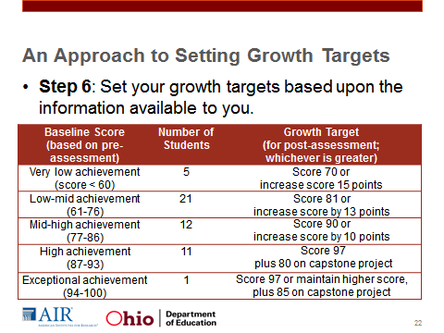
Slide 25  At this point, we have gone through the entire process for writing an SLO. Review Promising Practices. | 